## Merchant Name: Responsive

## <https://app.hubspot.com/contacts/43610657/record/0-3/34893564005> Implementation POC: Royce *(IM to fill) Michael Wardrop* CX POC: *[IMP to Add]*

### 

### 

| Notes Sections   *(AE to fill if they have, Implementation to be completion DRI on handoff)*   * Info on how merchant bills * Upfront platform fees + seat based usage + one off service offerings   1) What is the merchant temperament?  Kind, process oriented. Large team with dedicated resources for implementing  3) What are the Tabs features that the key POC cares about?  SFDC + NS + Stripe integrations  Invoice automation  Cash application |
| --- |

### Billing model *(Entire Section: Implementation to fill section)*

* Are there unique things about the customer creation process for this merchant?
* Information on how merchant bills
* How contract is broken up
* One off things to know about the merchant

### Contract Processing Steps *(Entire Section: Implementation/Success to fill Post-Go Live)*

1. Steps to process

* **Locate BTs** in the subscription and one-time purchase summary tables typically labeled "SUBSCRIPTION PURCHASE SUMMARY" and "ONE TIME PURCHASE SUMMARY"
  + Ok to process BT for change orders on the change order contract and not the original contract
* **Create one BT per line item** listed in either section:
  + Each subscription or one-time product line should be its own BT
  + Only create a BT if the price is not $0 e.g. you would only create BT for “Responsive Projects” in the below screenshot

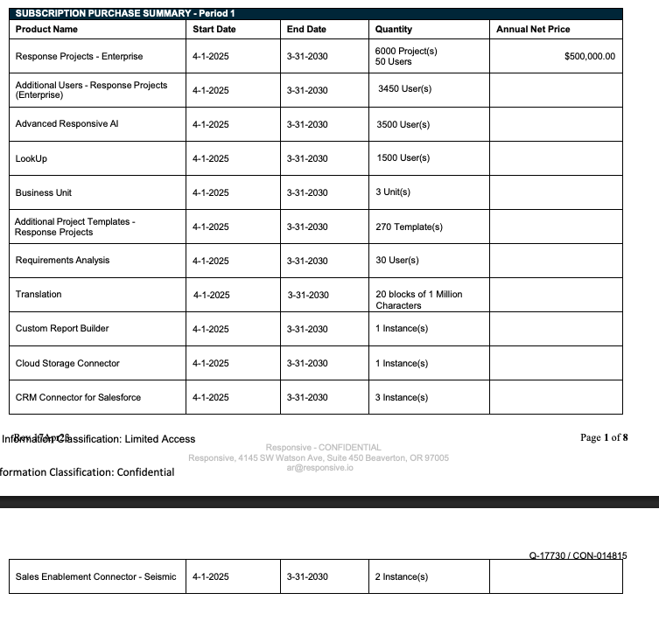

* **Item Name**: Use the product or service name from the "Product" column
* **Item Description**:
  + if there is *subscript* under a product name, use that or if quantity column lists multiple items
  + Otherwise leave blank. Make sure it doesn’t say “null”
* **Quantity**: Use stated quantity; default to 1 if not specified
* **Service Start Date**:
  + Use the Effective Date
* **Months of Service**:
  + Use the “Subscription Term” for subscription products or the # of months between the “start date” and “end date” (these should match)
    - This should also match the time period between the “effective date” and “contract expiration date”. Please flag to me if it doesn’t



* + - ***Exception*:** for change orders, you should use the # of months between the “start date” and “end date”. It won’t match the “subscription term”
      * Example screenshot here:



* + For Implementation and one-time fees, use the start and end date if specified; otherwise default to 1 month
    - E.g. this has contract (abb7c0ae-79fc-417d-abf9-7cac24e4b28c) has implementation services (screenshot below) with stated start and end date 3 months apart
    - Months of service would be 3



* + This contract (0e43c4e6-3444-4171-bc4b-65466fcf7009) also has implementation fees but doesn’t note start and end date
    - Months of service would be 0



* **Integration Items:** Match the Item Name *inclusive* of the subtext underneath (if there is one); if no match in dropdown, leave blank
  + Integration item here would be “RFPIO Core Package: Included features, add-ons”30
* **Billing Start Date**:
  + Check “Billing Information” section and the “Customer Info” sections
    - One of these will state the invoice schedule
    - First invoice usually aligns with the service start date as the start date
      * For “annual, upfront” billing cadences that are multi-year subscriptions, check contract for context clues on whether entirety of subscription is billed at once or annually
* **Total Price**:
  + Use the line-item total after discounts
  + Double check that the AI did not make the BT “usage”; change these to flat. Have not come across actual usage BT in the contract - if you see any, please flag to me
* **Frequency**:
  + Match the billing cadence stated in the “Billing Information” section
  + For one-time and implementation fees, use 1 period and match frequency to the service period
    - If no service period is stated (e.g. your months of service was 0), use "None" for one-time fees
* **Net Terms**: Use the stated payment terms; default to 30 if not specified
* **PO number:** If there is a PO number on the contract, add to the invoices that are generated
* **Ignore**:
  + Feature lists or exhibits that describe bundled capabilities — these are not standalone BTs e.g. the screenshot below is one BT

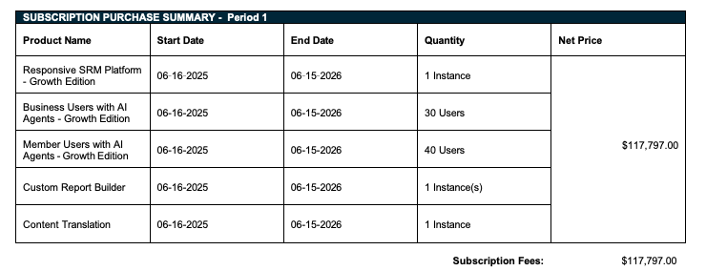

* + Currency conversion language
    - Example contract: 0e43c4e6-3444-4171-bc4b-65466fcf7009
    - Customer is based in the UK - contract is in $
      * BT should be processed as is (in $). The merchant will do the conversion themselves
      * This customer already existed (pulled in from netsuite) and the currency is in $$ so that’s fine. **However,** if you are *creating* a customer, please assign the current currency (£ in this case)
    - 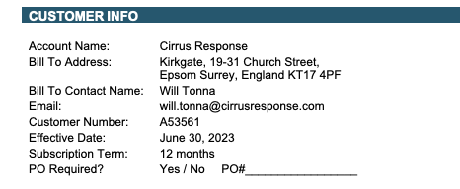
* Example Contracts:
  + Abb7c0ae-79fc-417d-abf9-7cac24e4b28c
  + 0b53e739-0c5c-4295-aa67-59231d015fc0
  + D712c551-43cc-4a21-819b-2cb15342073d
  + 0e43c4e6-3444-4171-bc4b-65466fcf7009
  + 5c5a4fd3-a78b-4c12-8998-f48b9aa21e5c

1. Anything to ignore in contracts?
2. Specifics processing things the merchant has requested that may differ by contract (e.g. always back-date invoice date to final day of the month)
3. Default Service Term
   1. If None Listed, Ops Default is 1 Year
4. Default Net Payment Terms
   1. If None, Ops Default is 0
5. Default Billing Frequency
   1. If None Listed, Ops Default is Monthly
6. How do we handle taxes as a line item?
   1. If None Listed, Ops Default is every tax line item becomes a BT

### Events Processing (if necessary) *(Entire Section: Implementation/Success to fill Post-Go Live)*

* Any important information on events billing

Integration Items Processing (if necessary)  
*(Entire Section: Implementation/Success to fill Post-Go Live)*

* What are the instructions for assigning integration items?
* Example: All Statsig integrations items should be labeled as “Sales”
* Example: All “Pinata” integration items should be labeled as “Software Subscription Bundle” unless otherwise noted by Merchant

Post Processing Communications (if necessary)  
*(Entire Section: Implementation/Success to fill Post-Go Live)*

* Does the Ops Team need to notify anyone on the team re: completion of processing batches in Implementation or Active phase?
* Who needs to be notified and when?
  + Example:
    - Who: Customer Success [Azmat Aziz] needs to be notified
    - Where: Messari internal merchant channel
    - When: contracts are processed [Merchant Phase: Active]

### Customer Information *(Entire Section: Implementation/Success to fill Post-Go Live)*

* Any important information on specifics customers of this merchant
  + Special memo’s certain invoices require
  + Invoice changes due to merchant/customer relationship

### Feature Requests *(AE to fill for all requests prior to Imp handoff, Imp to fill prior to go-live/Success to fill to fill Post-Go Live)*

* FR 1
  + What is it
  + Why it's important
  + Urgency

### Merchant Calls *(AE to fill for all videos prior to Imp involvement, Imp to fill prior to go-live/Success to fill to fill Post-Go Live)*

* .ROI deck: x<https://docs.google.com/presentation/d/1WvUcVLUcfd7CuLjwQlbBE17RgJy1Pu4534V0Tra5rMY/edit#slide=id.g3435dde1ffa_0_68>
* .<https://us-56595.app.gong.io/call?id=7968878822609190585&email_type=call-ready-notification&xtid=v9em320ixnz80n1ya8>
* .